Abstract

**Project Report**

**Introduction**

Factors influencing customer retention are important in the study of consumer relationship conception which has implications for organizational business strategy and regulatory policies. Customer retention is one of the main relationship marketing objectives. Currently the perception and application

of customer retention is significantly valuable for companies. Thus, in order to perceive and apply marketing principles in practice relevantly, it is important to ground theoretically and assess empirically customer retention.

The aim of the report is to create a theoretical model of customer retention and to prove it in

practice. The research results showed that there is a statistically significant positive

correlation between factors identified in the theoretical model: such as product offerings, convenience, product information, trust factors, monetary benefits, gratification, deals, social etc

1. Introduction

Methods

2. Method

To achieve the aim of this report, data were collected from 269 respondents. The data was analysed by a quantitative questionnaire survey method. In order to test all the relationships between variables and results. We had implemented various visualization techniques to draw conclusions. Feature engineering method were adopted to get top 25 features which are closely related with the recommendation of the website. During this we have implemented standard scalar to balance the data and transform the skewness.

Analysis

On observing all the features of the data set we analyse that recommendation of a particular website or retention of a customer depend upon various values such as hedonic values and utilitarian values.

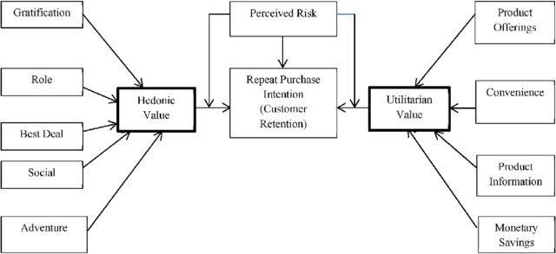

In utilitarian value there are multiple factors that affect the customer to build their mind to repurchase the things are

**Product offering:** Most of the time customers are looking for lucrative offers, discounts, coupons, cash backs etc. These are the factors that motivate the users to repurchase the products again.

**Convenience:** This is another factor that makes the customers to make a repurchase. Website providing good services such as easy replace, refund, easy to understand, easy to book, return motivates the customers in building their mind for repurchase.

**Product information:** It is most important point for a service provider to build a trust of customers by providing complete information about the product, making their information or data secured, etc.

**Monetary Saving:** When we are buying a things there is a profit and loss statement in our mind.  If a customer gets a saving on their purchase then it’s pretty obvious that he/she will become a loyal customer.

There are some hedonic values that influence the customers to make a repurchase are

**Gratification:** If a customer is satisfied with the services and product then it will influence the customer to make a repurchase.

**Best Deal:** Once a customer will get a best deal then it will build an impression on a customer that definitely he/she will get the best deal again. This helps in retention of a customer.

**Social:** References matters allot. It’s more important to build new customers then retaining old ones.. If a customers feel that the services and products are good then he/she will recommend it in their social platforms such as facebook, instagram,..personally to their friends.

**Adventure**: Sometimes customers want to explore something else. In that case most of the time retention occurs.

**Conclusion**

On visualizing different bar graphs, we get to know that amazon and flipkart are the website which satisfies the maximum  parameters such as product offerings, convenience, product information, trust factors, monetary benefits, gratification, deals, social etc. This makes these website more popular among the people. Myntra is sharing third position among the people to buy any product. Amazon is most popular website among the people due to their services and meeting the satisfaction level of the people.